Chapter 17, Solution 24.

(a) This is an odd function.

a_{o} = 0 = a_{n}, T = 2π, ω_{o} = 2π/T = 1

b_{n} = 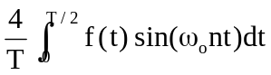

f(t) = 1 + t/π, 0 < t < π

b_{n} = 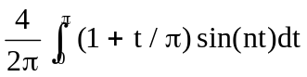

= 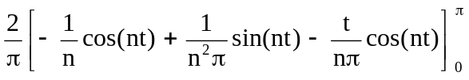

= [2/(nπ)][1 − 2cos(nπ)] = [2/(nπ)][1 + 2(−1)^{n+1}]

a₂ = 0, b₂ = [2/(2π)][1 + 2(−1)] = −1/π = −0.3183

(b) ωn = nω_{o} = 10 or n = 10

a₁₀ = 0, b₁₀ = [2/(10π)][1 − cos(10π)] = −1/(5π)

Thus the magnitude is A₁₀ = 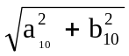 = 1/(5π) = 0.06366

and the phase is φ₁₀ = tan⁻¹(b_{n}/a_{n}) = −90°

(c) f(t) = 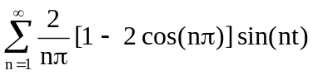π

f(π/2) = 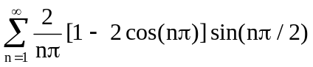π

For n = 1, f₁ = (2/π)(1 + 2) = 6/π

For n = 2, f₂ = 0

For n = 3, f₃ = [2/(3π)][1 − 2cos(3π)]sin(3π/2) = −6/(3π)

For n = 4, f₄ = 0

For n = 5, f₅ = 6/(5π), ----

Thus, f(π/2) = 6/π − 6/(3π) + 6/(5π) − 6/(7π) ---------

= (6/π)[1 − 1/3 + 1/5 − 1/7 + --------]

f(π/2) ≅ 1.3824

which is within 8% of the exact value of 1.5.

(d) From part (c)

f(π/2) = 1.5 = (6/π)[1 − 1/3 + 1/5 − 1/7 + - - -]

(3/2)(π/6) = [1 − 1/3 + 1/5 − 1/7 + - - -]

or π/4 = 1 − 1/3 + 1/5 − 1/7 + - - -

